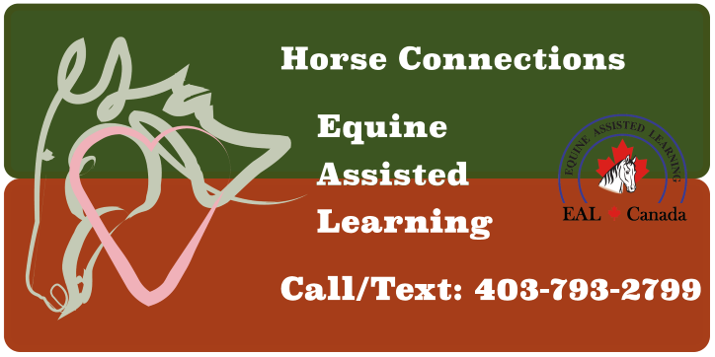

**Ladies Day Out**

**(Ladies Spa Day)**

Saturday, August 6, 2022 at 10 am – 2 pm

Location: Horse Connections Out Door Arena, Duchess, AB

(17 km North from the Brooks overpass on the Duchess HWY (873))

Have you been stressed lately? Feeling disconnected? Come for a low-key relaxing day spending time with calming horses and other ladies in a beauty setting. There will be time to connect with the horses, simple low-key activities and connect time.

You are invited to a day of relaxation and connection.

No horse experience necessary!

**Cost: $140**

Lunch is included.

For more information and to register contact:

Darlene Rempel at 403-793-2799

Email: darlenerempelconsulting@gmail.com